Yvette Hally Management

TEL: + 353 1 493 3685

FAX: + 353 1 493 3076

E-MAIL: yhmgt@eircom.net

ADDRESS:
121 Grange Road,
Rathfarnham,
Dublin 14

AGE RANGE: 20s

HEIGHT: 5’ 2’’

HAIR:Light Brown

EYE:Blue

SINGING Mezzo Soprano (Ian Adams & Mary Hammond))
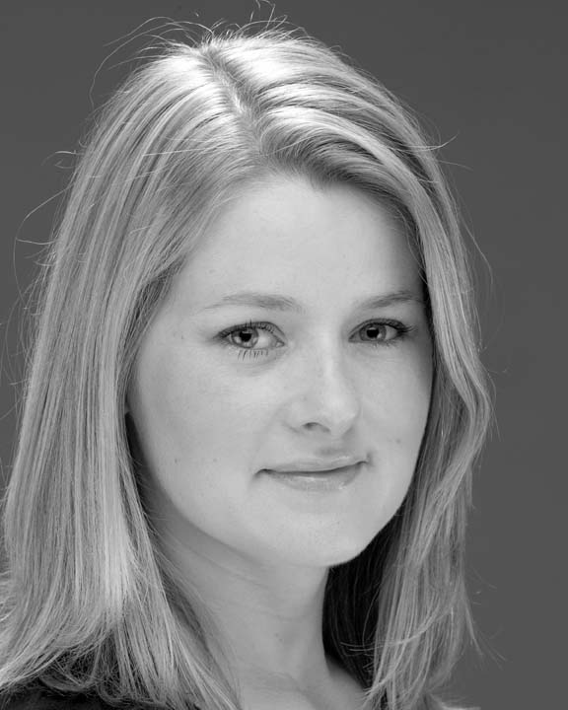

JENNY McGRATH
BRITISH EQUITY / SPOTLIGHT PG 4032

MUSICAL THEATRE ROLE DIRECTOR VENUE

Beauty and the Beast Belle John Newman Civic Theatre Chelmsford, UK

Pinocchio Jiminy Cricket Sylvia Carson Palace Theatre, Westcliff UK

Joint is Jumpin’ Lead Vocalist Davor Golub PPAS Shaw Theatre UK

Veronica Ugly Sister Richard Burke PPAS Shaw Theatre UK

Horray for Hollywood Sal Jannyne Eaton – Jones Memory Lane Theatre Co. UK

Chigago Mona Zoẽ-Ann-Phillips Arts Theatre UK

Pentimenti Ensemble Bryan Flynn Gaiety Theatre, Dublin

Calamity Jane Katie Brown Jo Mangan Holy Faith Hall, Clontarf,

THEATRE

Domino Verlag Bus Conductor Cheryl Blaise Tour of Southwest
Germany
Skin Work Various Rainbow Productions Various UK

FILM / TELEVISION

Fair City Sharon Hayden Various RTE

Elvis has left the Building Daughter Mark Phillips Irish Film Institute (Winner of
Best Drama 2001)
The Cassidy’s Pupil Graph Films RTE

TRAINING: Star Tek. The London Drama & Language School .

OTHER SKILLS

Singing: Working Range F-High A

Accents: Excellent range, including Dublin (Native) Southern Irish, English, RP, Liverpool & Various American.

Provisional Driving Licence

